Checking files are automatically merged

1.Download the git-flow tool

2.Create a working directory and initiate git flow init

Command: mkdir, git flow init

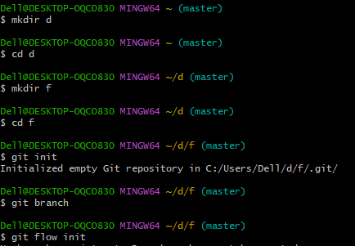

3.Check if the Master and Develop branch is created or not

c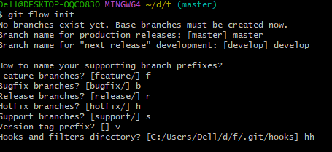

4.Start a new feature branch

Command: git flow feature start f

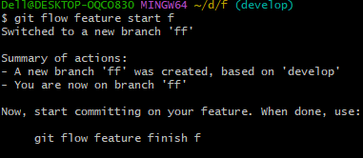

5.Create new files and commit file

Command: touch, git add, git commit –m

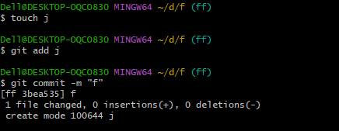

6.Now finish the feature branch

Command: git flow feature finish f

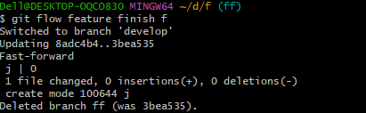

7.Check if files are automatically merged into develop branch

Command: ls

